**Critical Overview**

**P17207167**

**MEDS3109**

In this report, I will critically reflect on the project that I have produced for this module. My project was based on designing and building a responsive website. In further sections of the report, I will discuss and critically evaluate the technologies I used in building my responsive website. I will reflect on aspects of the website that have worked well as well as on aspects that could have been improved. My inspirations, drawings and designs of the website can be found in Appendix 1 and 2 below the conclusion.

As I specified in my project identification, my main goal was to make my website responsive because I was not able to make a responsive website in my second year and I wanted to learn new things that are essential to become a web developer. This year, I managed to make a responsive website and I believe that responsiveness is one of the strongest aspects of my website. However, the process of building the website was not that easy and I had some difficulties.

In building my website I used HTML, CSS and JavaScript. While coding, I was using Google Chrome. Therefore, some elements might not work properly in other browsers. This having in mind, If I had more time, I would make sure that the website and its design is compatible with every browser.

When I first started developing the homepage of my website, I was writing code for larger screens and then by using media queries, adapting it for smaller resolutions. After some time, I realised that it would be better to change my approach to mobile-first. Nowadays, the majority of people use their mobiles to surf the web so prioritising development for mobile devices seems to be a better idea. As McFedries (2018) says, “mobile-first thinking takes the opposite approach by ignoring (at least at the beginning) large screens and, instead focusing on what works best for mobile screens which, after, all, represent the majority of your page visitors” (p. 725). I changed my approach to mobile-first and then I used media queries to change the layout where necessary.

On one page of my website (band page), I wanted to include a video in the background instead of an image. However, having in mind that I should consider what works best for mobile phones, I decided to include the video only for larger resolutions. Not all mobile devices support autoplay video backgrounds, therefore, for mobile devices, I decided to use an image instead. This would provide a better user experience for people who use mobile phones as well as tablets and larger screens.

One of the important aspects of my website is the use of Flexbox, “also known as Flexible Box” (Man-Hendriksen, 2016, p. 4). Flexbox is a new method of positioning elements in horizontal or vertical stacks. This method made it easier for me to make the website responsive because I did not have to change many things in CSS. When writing code for a mobile I used the property ‘display: flex’ and then I positioned elements by using columns, the property ‘flex-direction: column’. Then, when writing my media queries for larger resolutions I just needed to change the property ‘flex-direction: column’ to ‘flex-direction: row’. This made the content to be displayed in rows which looks better on larger screens.

In terms of media queries which are used “to target particular CSS styles to particular device capabilities or situations”, I based them mostly on the website’s layout instead on specific devices because I think it is more practical (Frain, 2015, p. 20). I did it by resizing the browser’s window and then checking where my content did not look good and needed to be fixed. There are many devices with different screen resolutions so creating breakpoints only for specific devices would not be that reliable.

For mobile devices, I decided to use a mobile navigation menu, ‘toggle menu’. The toggle menu is a menu that is closed unless a person clicks on the menu button (‘hamburger icon’). JavaScript was used to make the menu toggle. When a resolution is larger than for a mobile, the toggle menu turns into a normal menu where categories are displayed in a row (this normal navigation was hidden for mobile screens by using ‘display: none’). Some JavaScript was also used in other aspects of my website, for example, to take the user to the top of a page after he clicks the ‘top’ button.

One of the challenges when creating my website was embedding a YouTube video. Since my website is responsive, I needed the YouTube video to re-size accordingly when the browser size changed. However, when I added the embed code <iframe> that I copied from YouTube, the video was cropped and had a fixed height and width. To fix that problem, I did some research and the solution I used was to wrap the code with a <div> element and add 56.25% padding to the <div> element. This prevented the video from being cropped and also made it responsive. I also resized the video by adding 80% of width and height because I did not want it to be fullscreen. Other important elements on my website were images. To make them responsive, I had to give images classes and use the properties like ‘width: 100%’ and ‘height: auto’ in CSS. This enables images to resize when the size of the browser’s window changes.

Part of coding was also styling elements on my website to make them express what my website is about. As I said before, my website is dedicated to Linkin Park and mental health. I had to combine these two topics in my design. To highlight that my website is also about mental health, I used green colour which represents mental health. You can notice that some elements and text is green (#3cb550). Also, I used the logo of the band on my website, which I also changed from black to green in Adobe Illustrator. These small things helped me to highlight the purpose of the website what I think is also important.

Moreover, the main font that I used on my website is called 'Open Sans Condensed', sans-serif; which I imported from Google Fonts. I decided to use one font across every page because it looks better and make the website consistent. One exception is the ‘band page’ where the text ‘Linkin Park’ uses the similar font to that of the band in their logos. Importing fonts from Google Fonts was really straightforward. I just needed to copy and paste some code into the <head> of my HTML document (for example, <link href="https://fonts.googleapis.com/css?family=**Roboto**&display=swap" rel="stylesheet">) and then paste some CSS code with the name of fonts. Also, icons that I used on my website are from ‘fontawesome.com’ where there is a huge library of free icons. Similarly, I had to put code from the website into <head> and then copy and paste a code of an icon and put it where I wanted it to appear in <body> of HTML document. Icons can be also styled in CSS, so I styled them as well.

Also, as I discussed in my project specification, I wanted my website to have minimalist design, so I was not planning on including many transitions. Therefore, there are only a few of them like changing colours of the buttons or icons on hover, or when you hover over the navigation menu (large resolutions), there is a transition with a nice effect of underlining the text. Moreover, there is a simple transition when you hover over fan-art images on the homepage. For example, I used the property ‘transform: scale(1.2)’ to zoom in the images on hover.

There are some aspects of my website that I think could be improved. If I could I would improve the audio player and its design. Below the audio player, there is a list of albums of Linkin Park. A good thing to implement would be to play songs of a particular album after users click on an album, and then use the audio player to change songs. However, this is more advanced and probably needs JavaScript. Therefore, I still have many things to learn.

One mistake I made while building the website was creating a few CSS folders instead of one. However, it was before I started building my third page, so I did not have to change as many things to fix it. I fixed everything, and now every style is included in one CSS folder. I am not exactly sure why I made this mistake, but I am aware that it was not a smart idea. Undoubtedly, one CSS folder keeps everything more organised.

To sum up, I think that my website looks and works well. As I mentioned, my main goal was to make it responsive. I managed to do that; therefore, I am satisfied with the final result. There are some things that I did not use in my project as much as I hoped to (for example, jQuery). As this was my first responsive website, I wanted to take everything step by step, therefore, I resigned from using some technologies.

**Appendix 1**

**Inspirations**

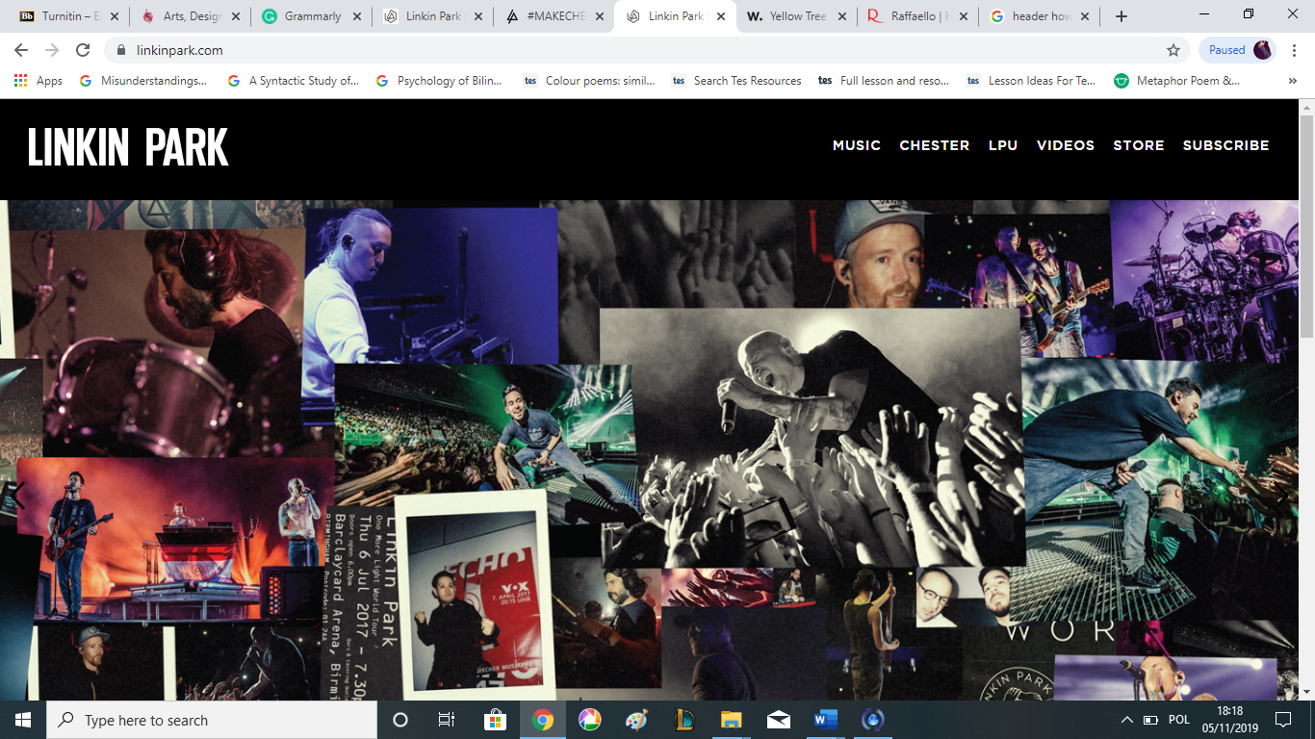

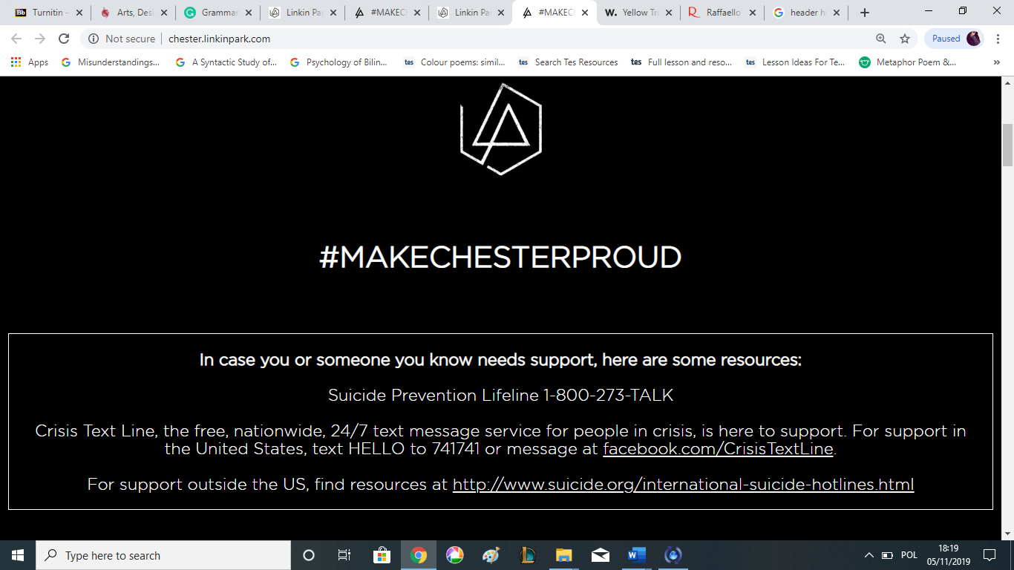

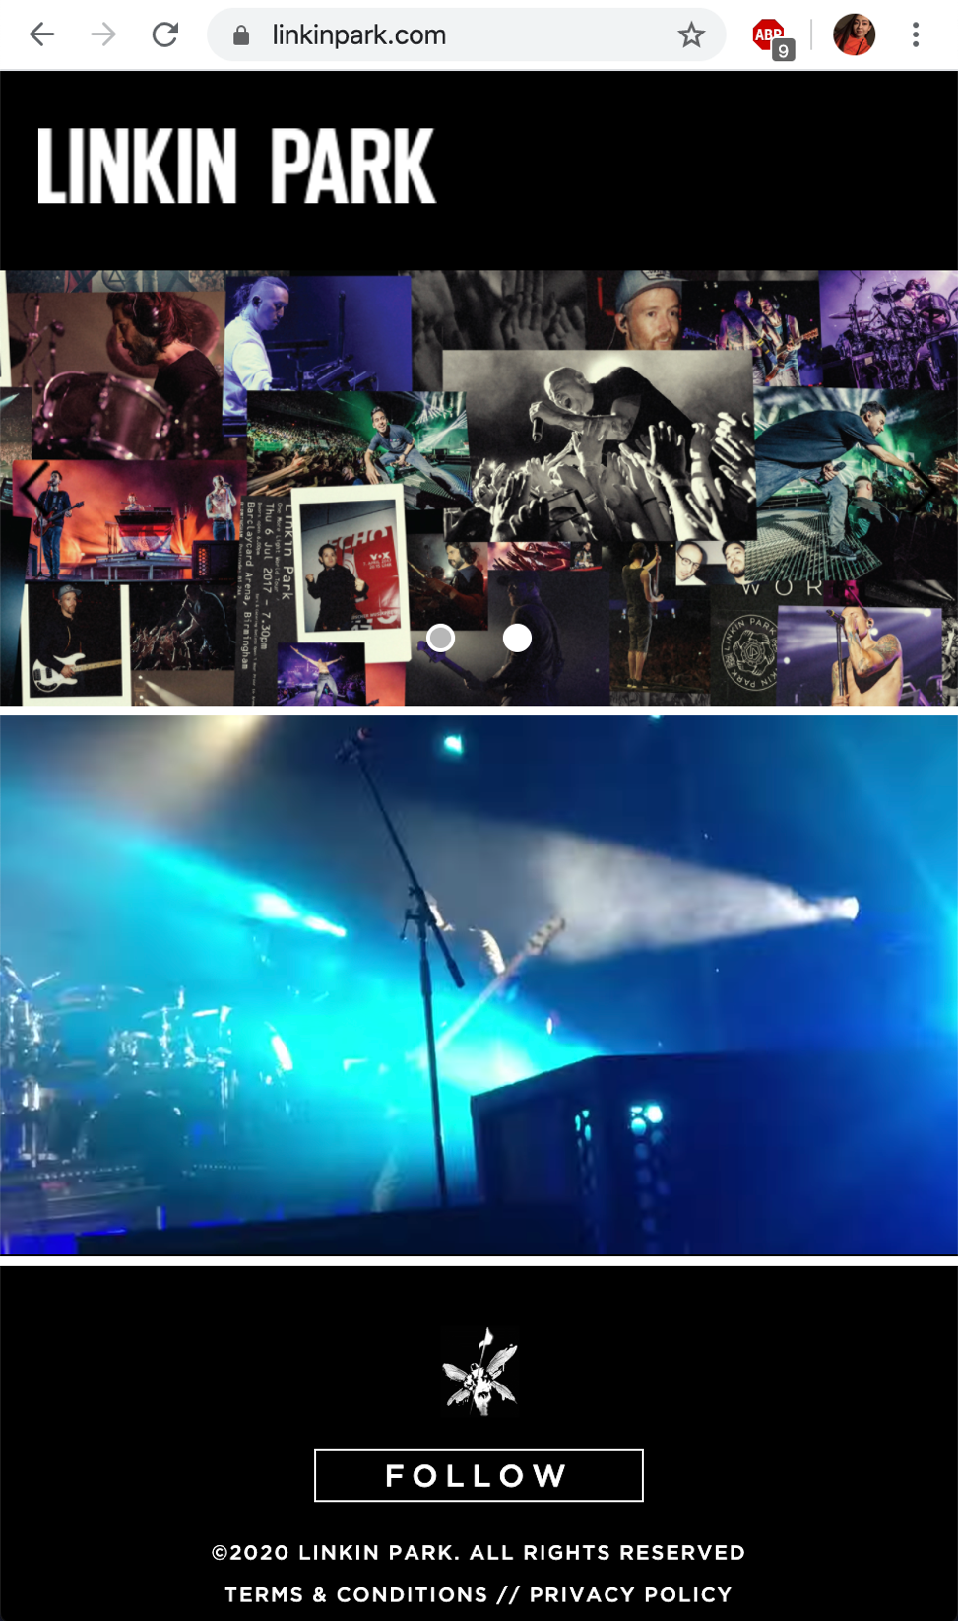

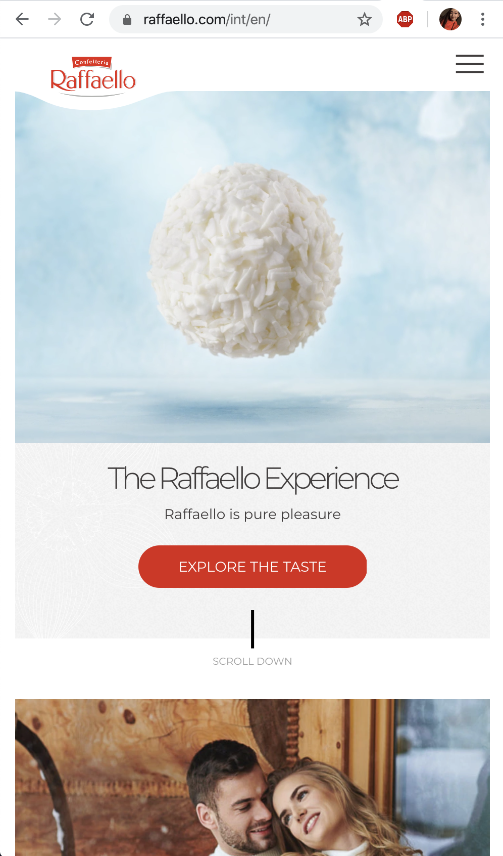

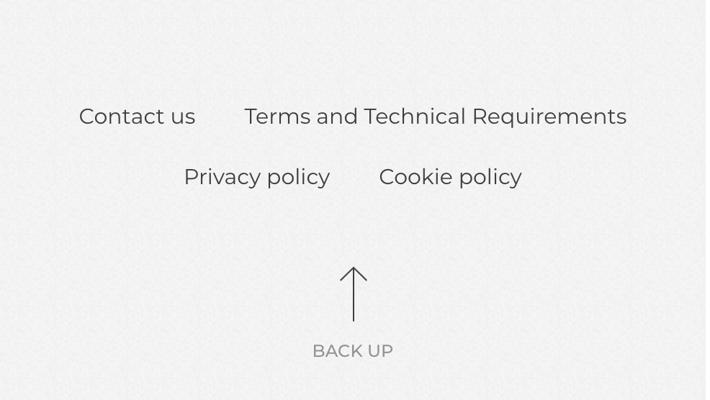

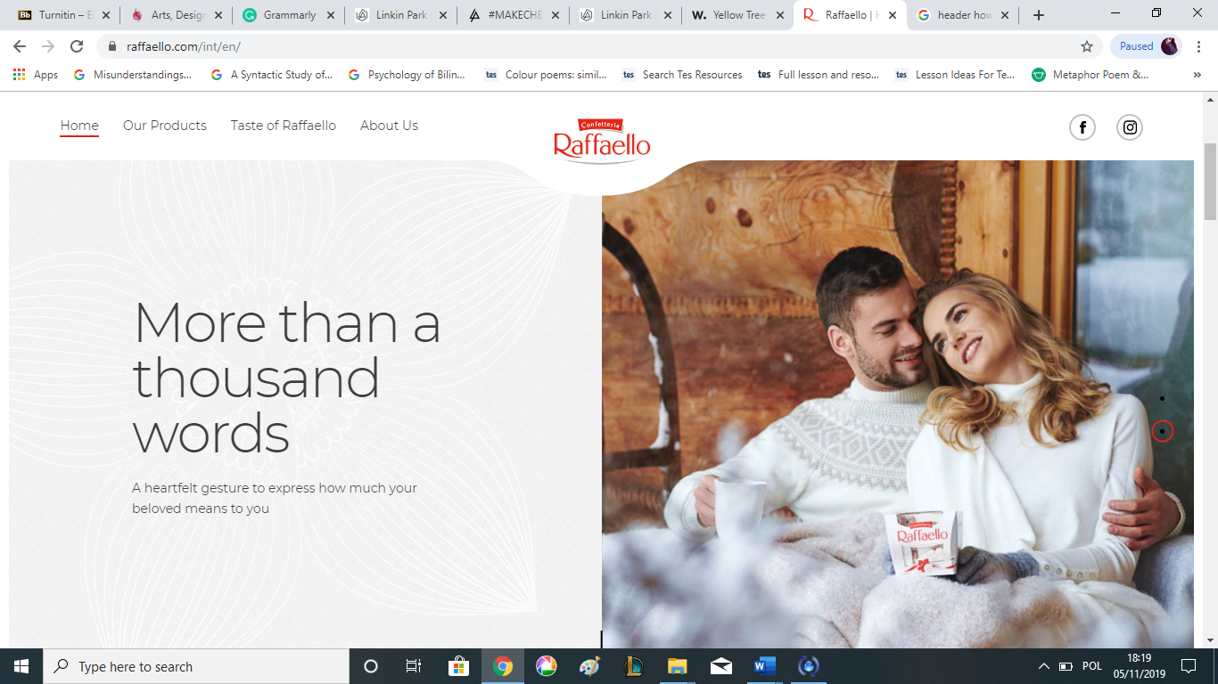

**Appendix 2**

**Drawings and designs made in Adobe Photoshop and Illustrator**

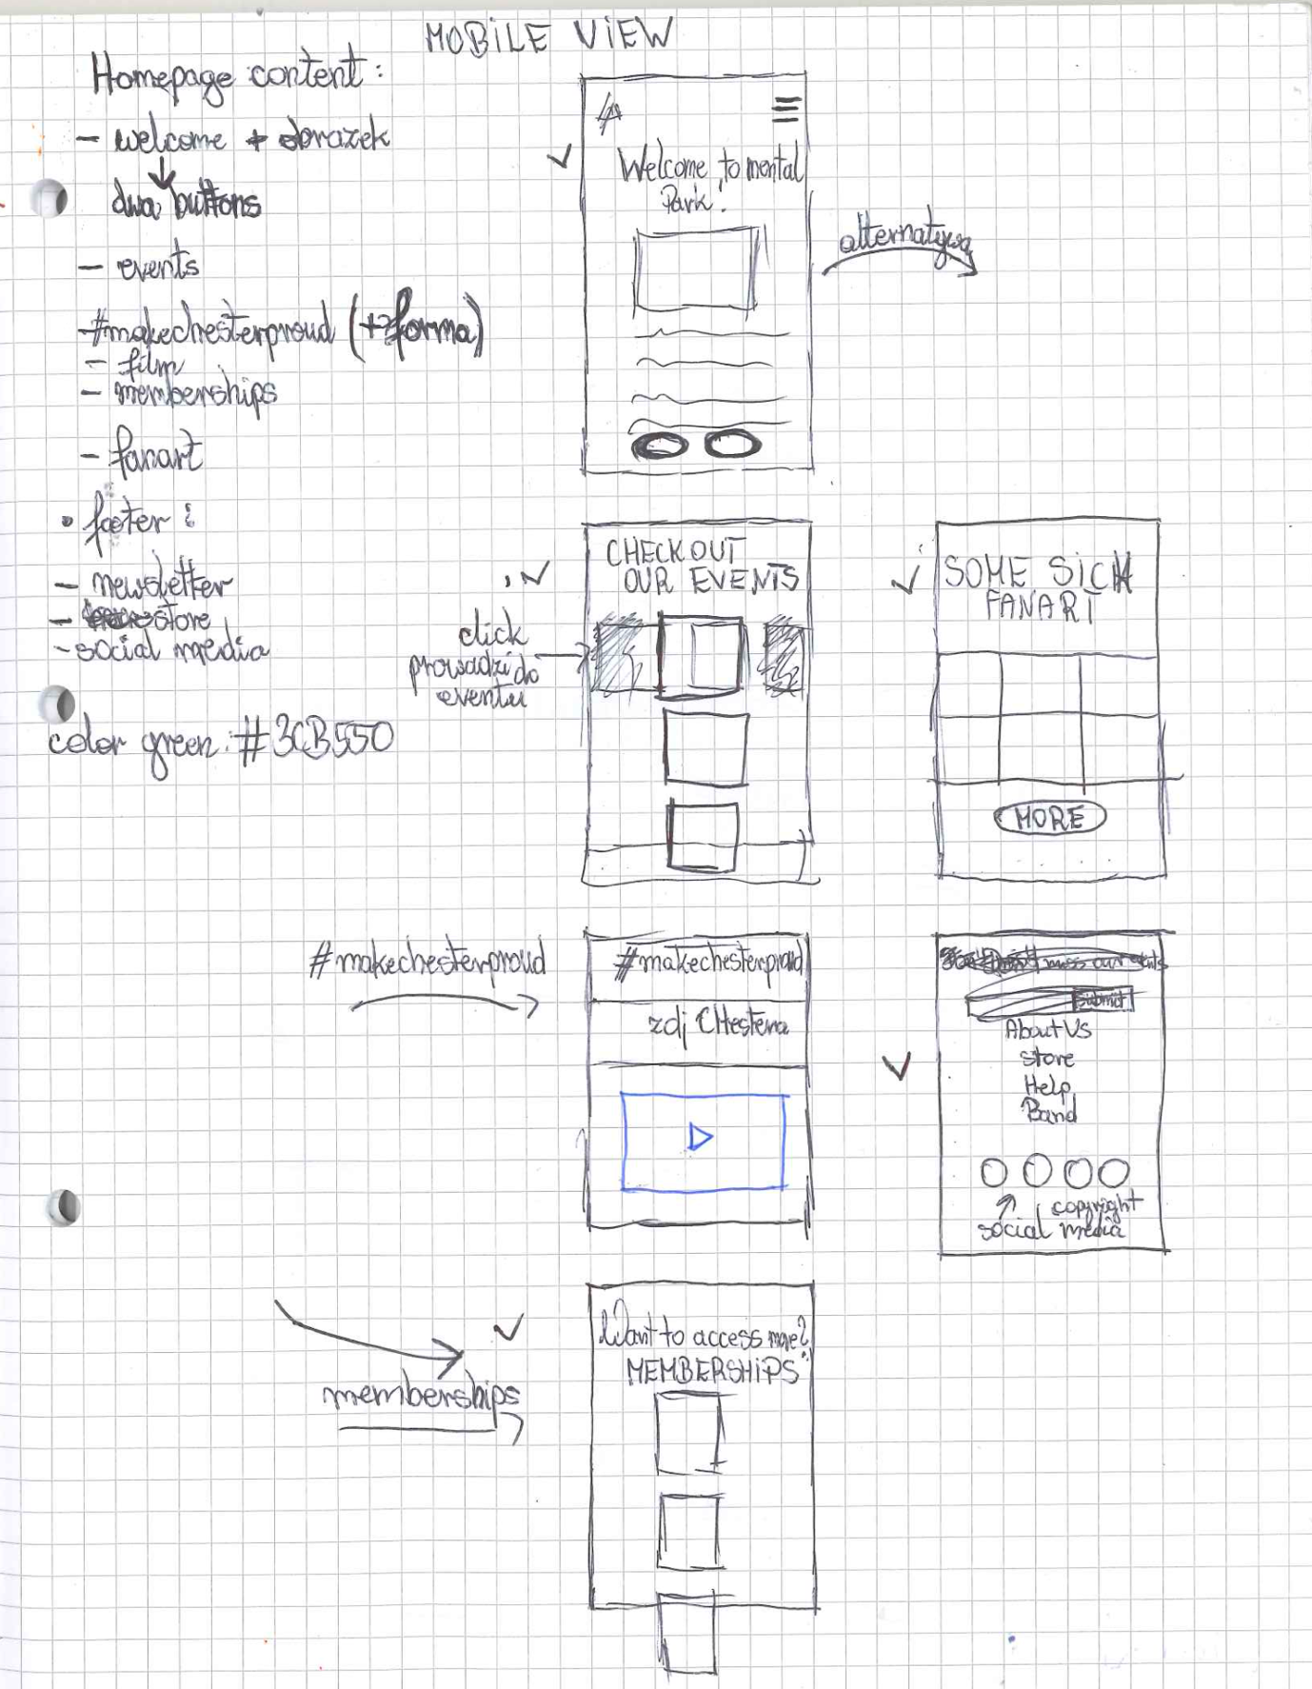

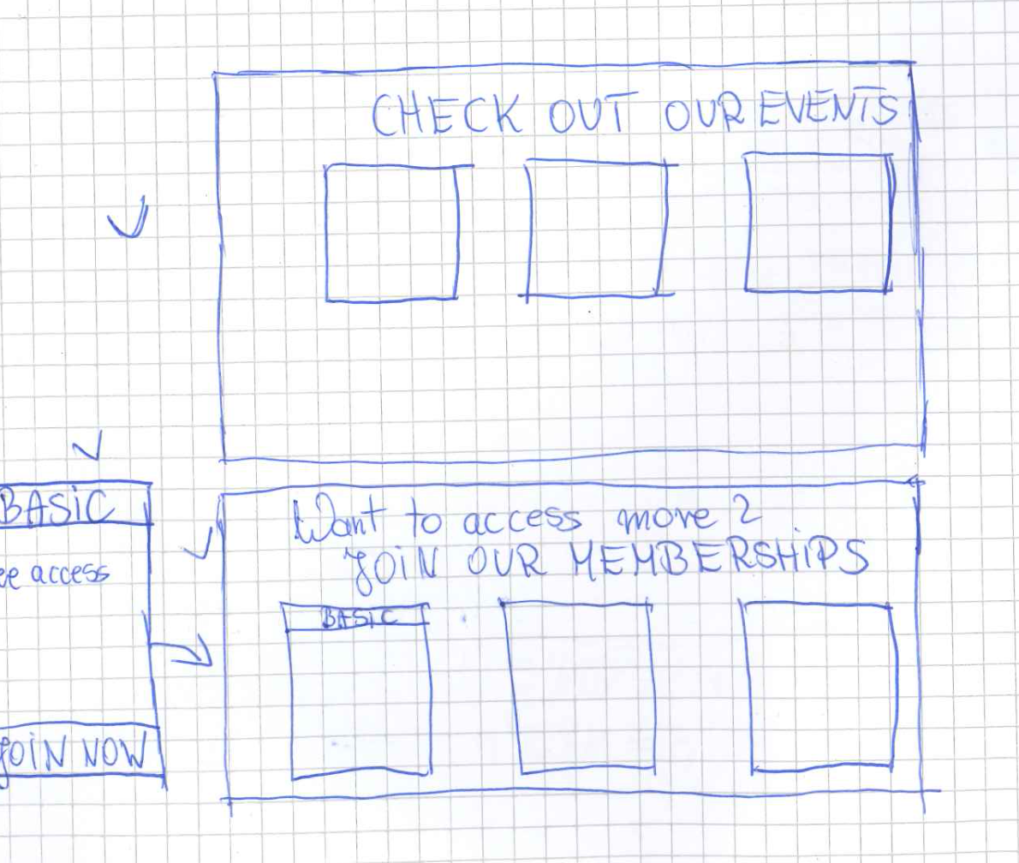

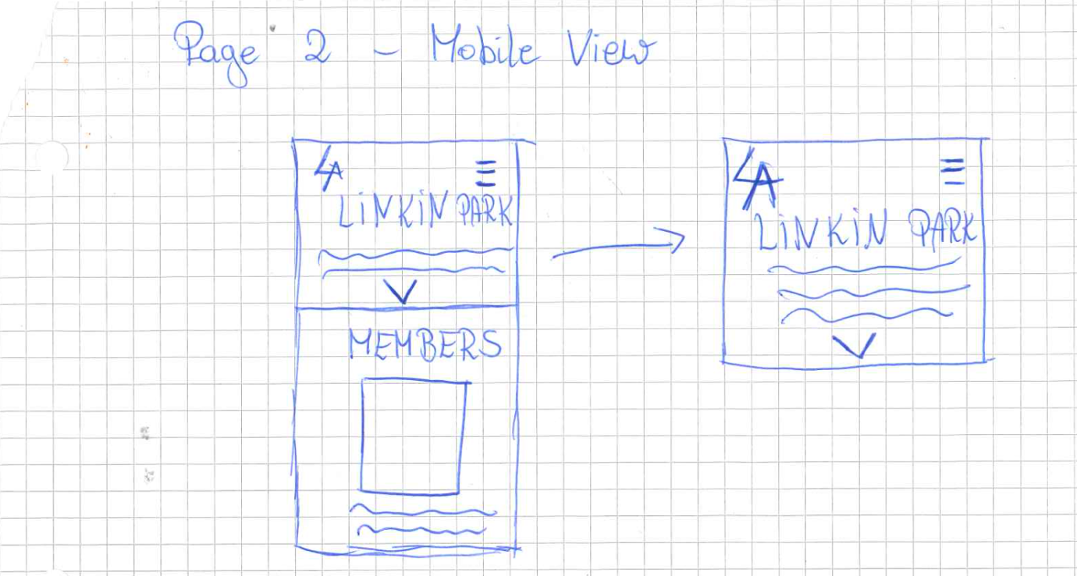

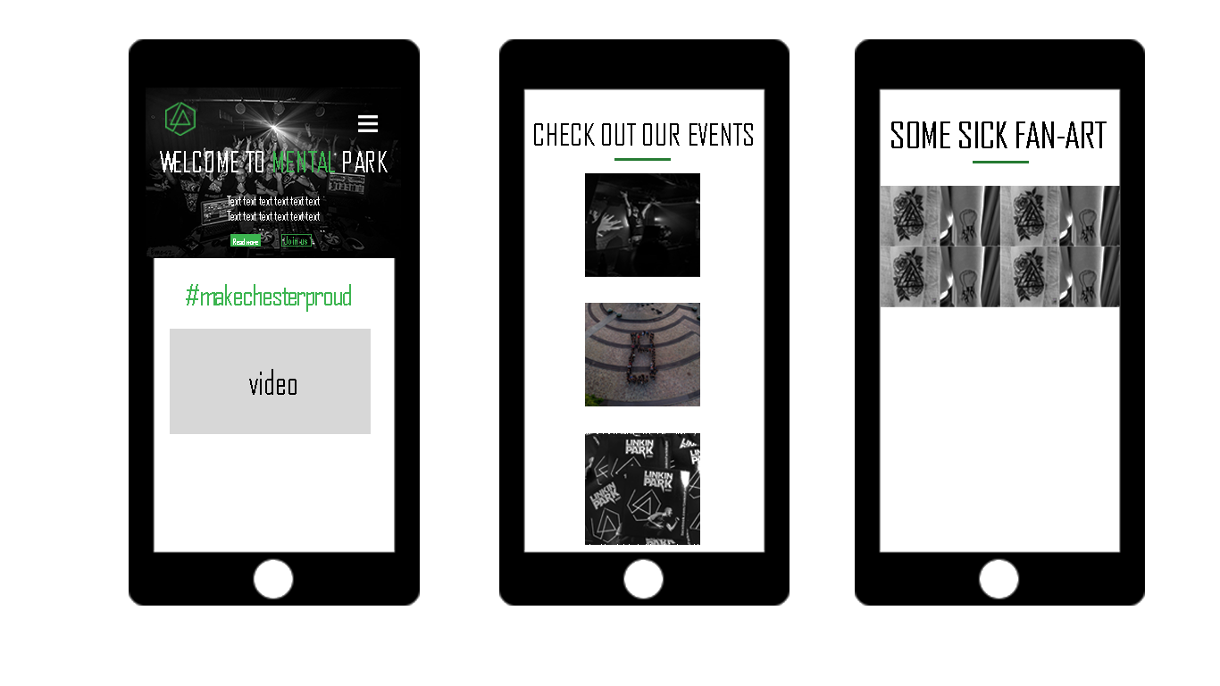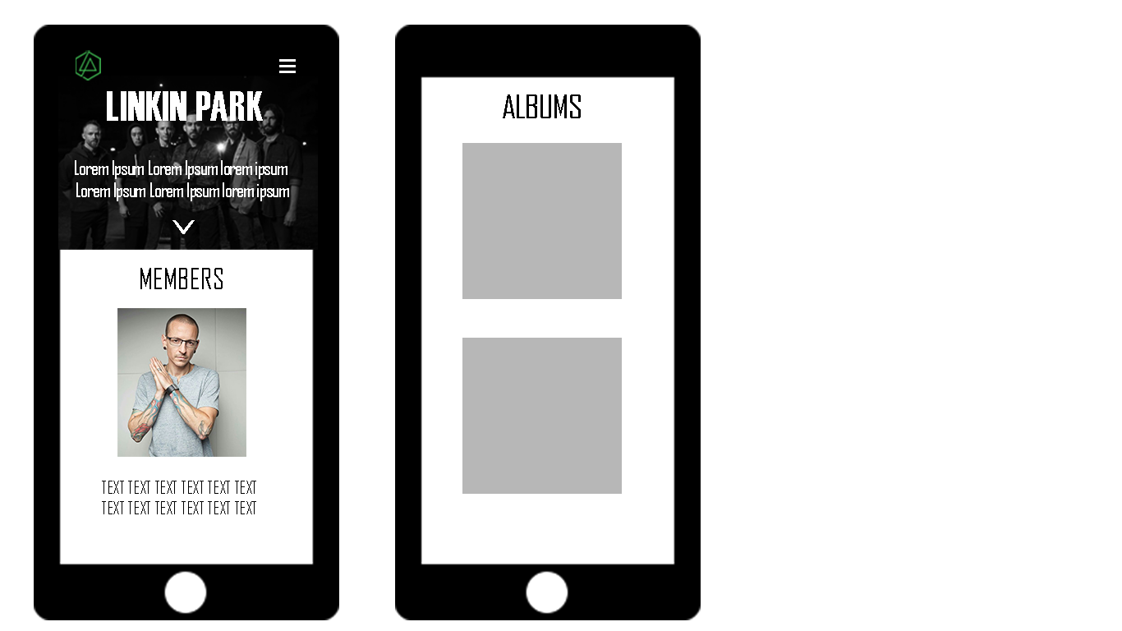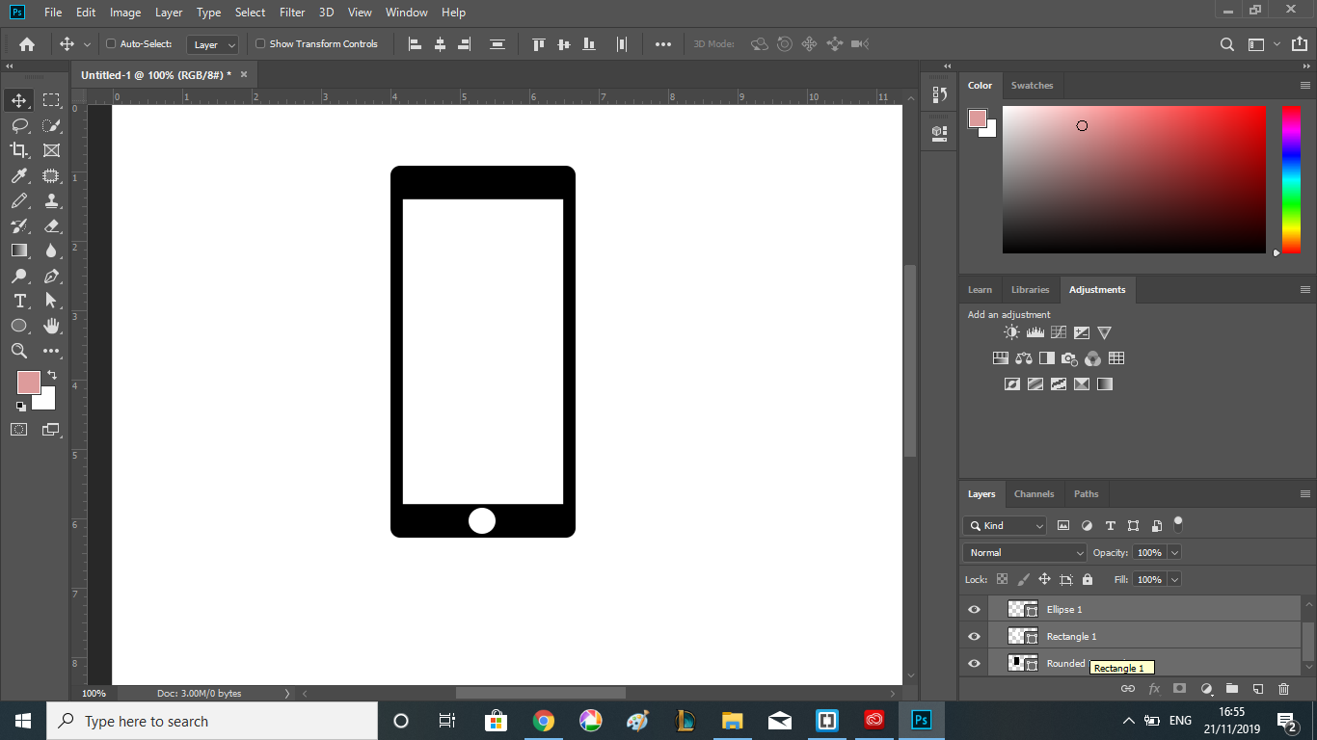

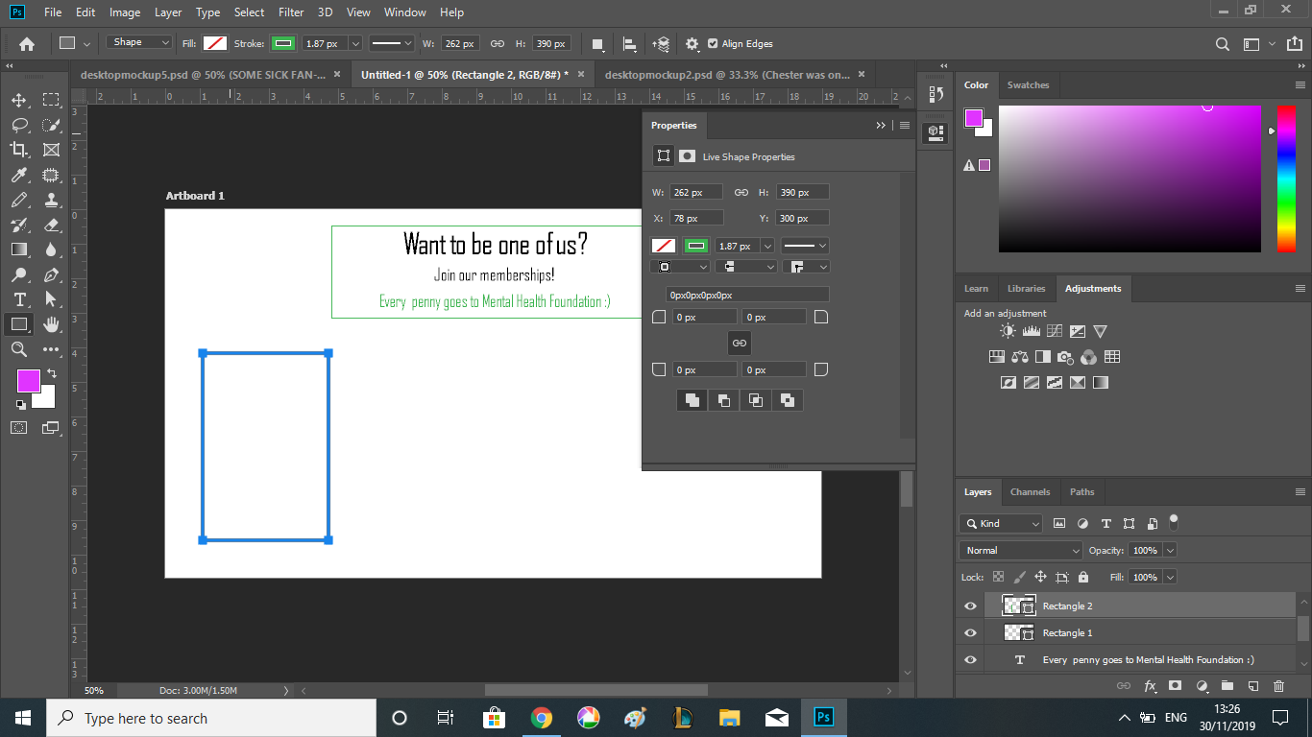

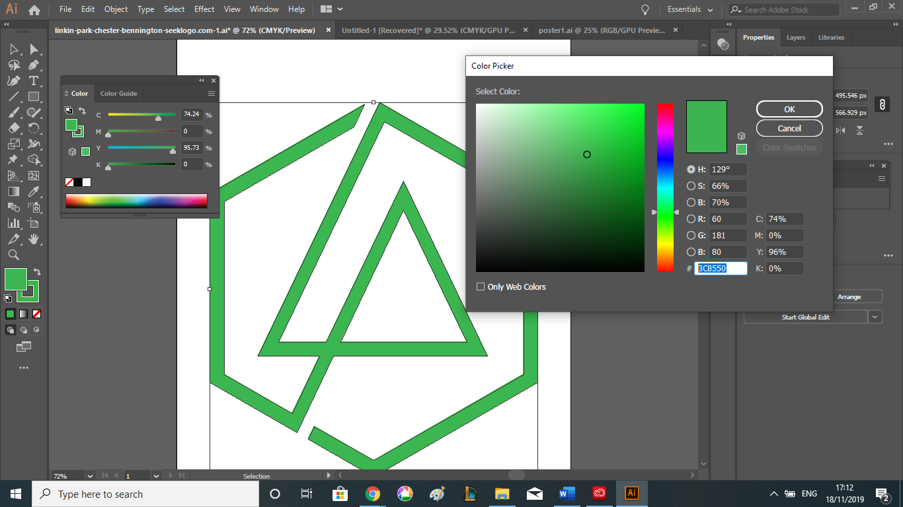

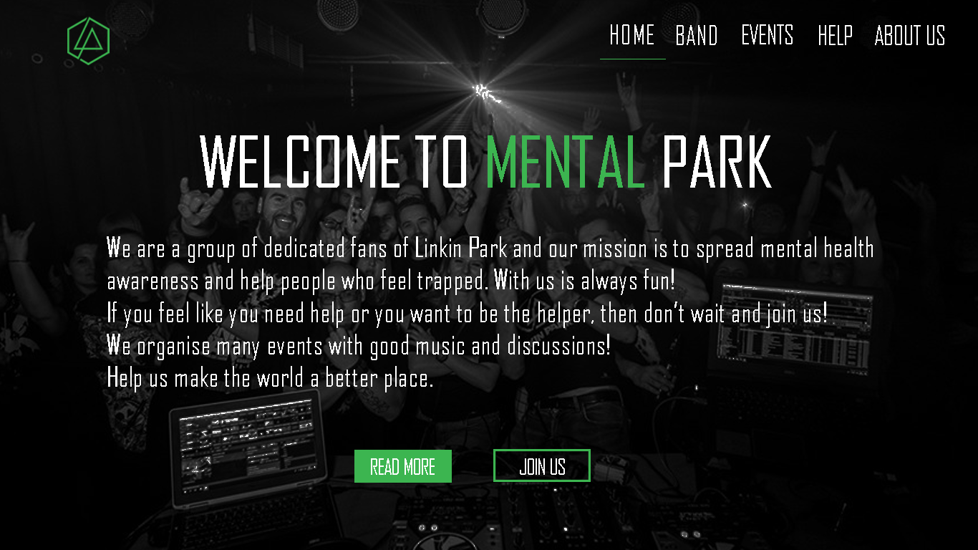

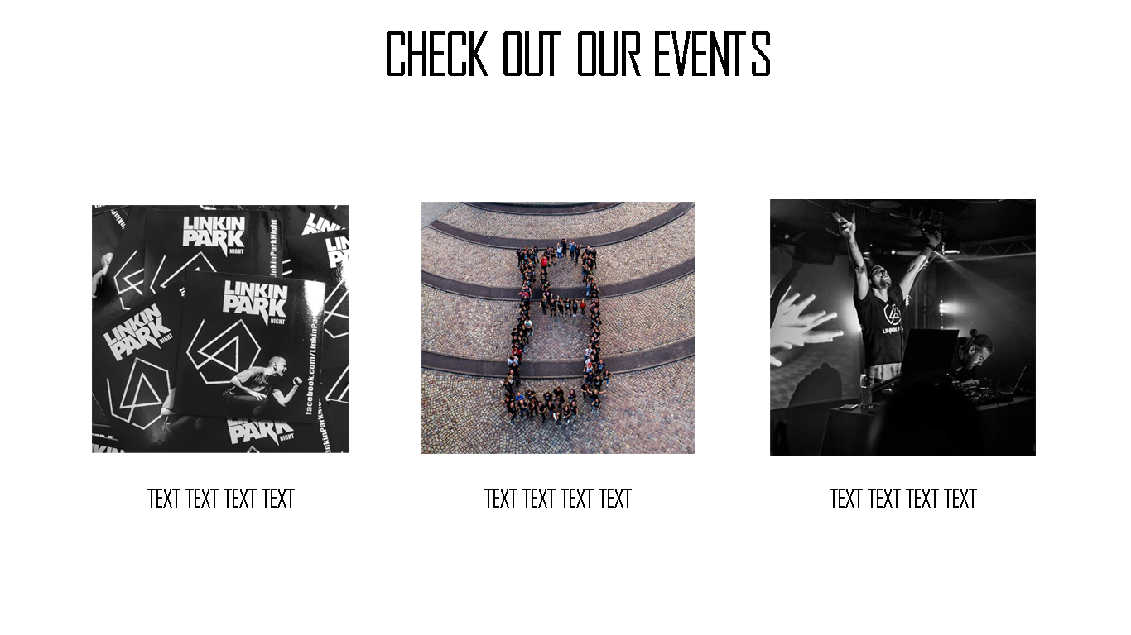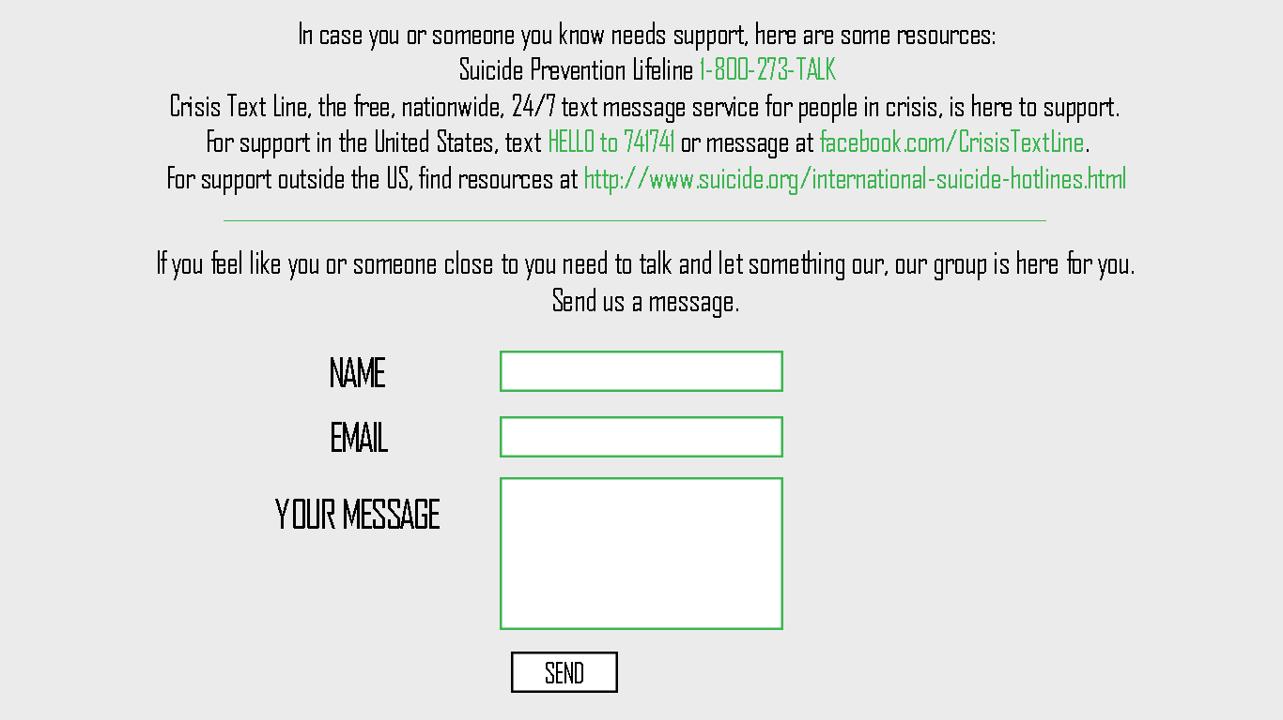

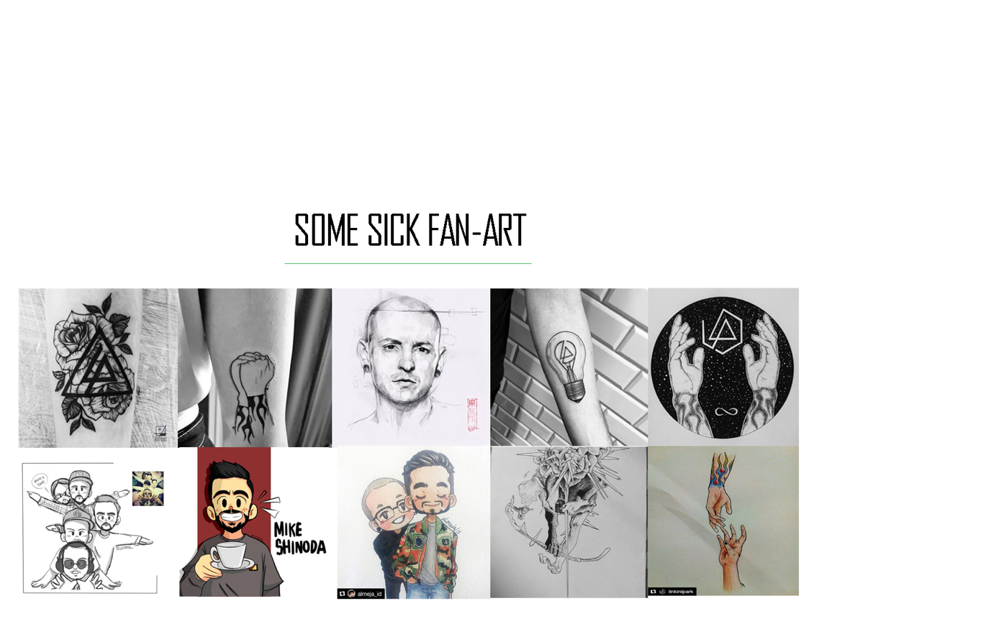

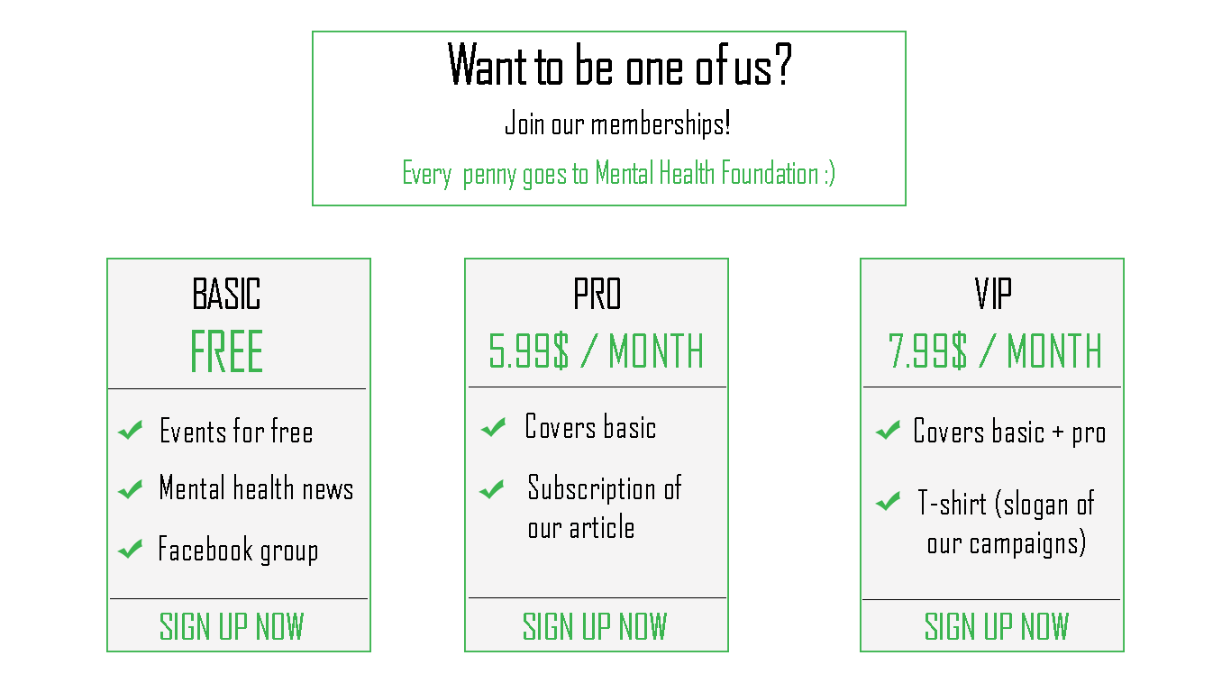

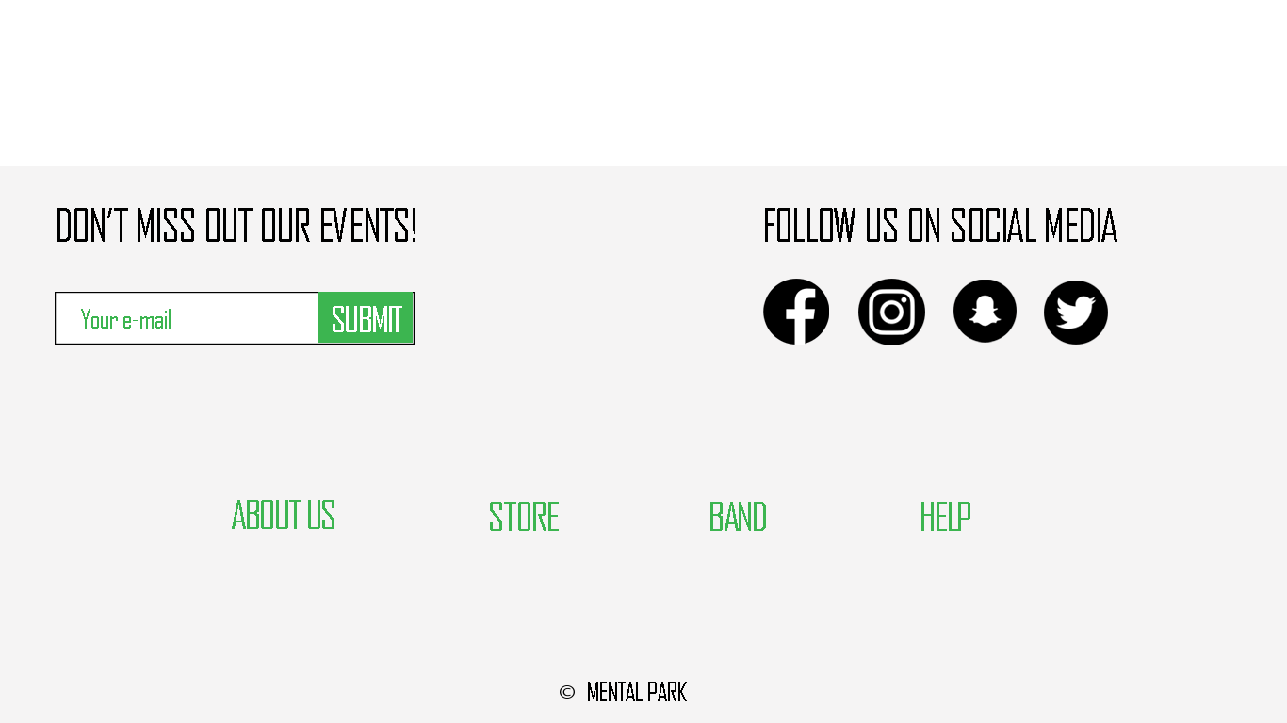

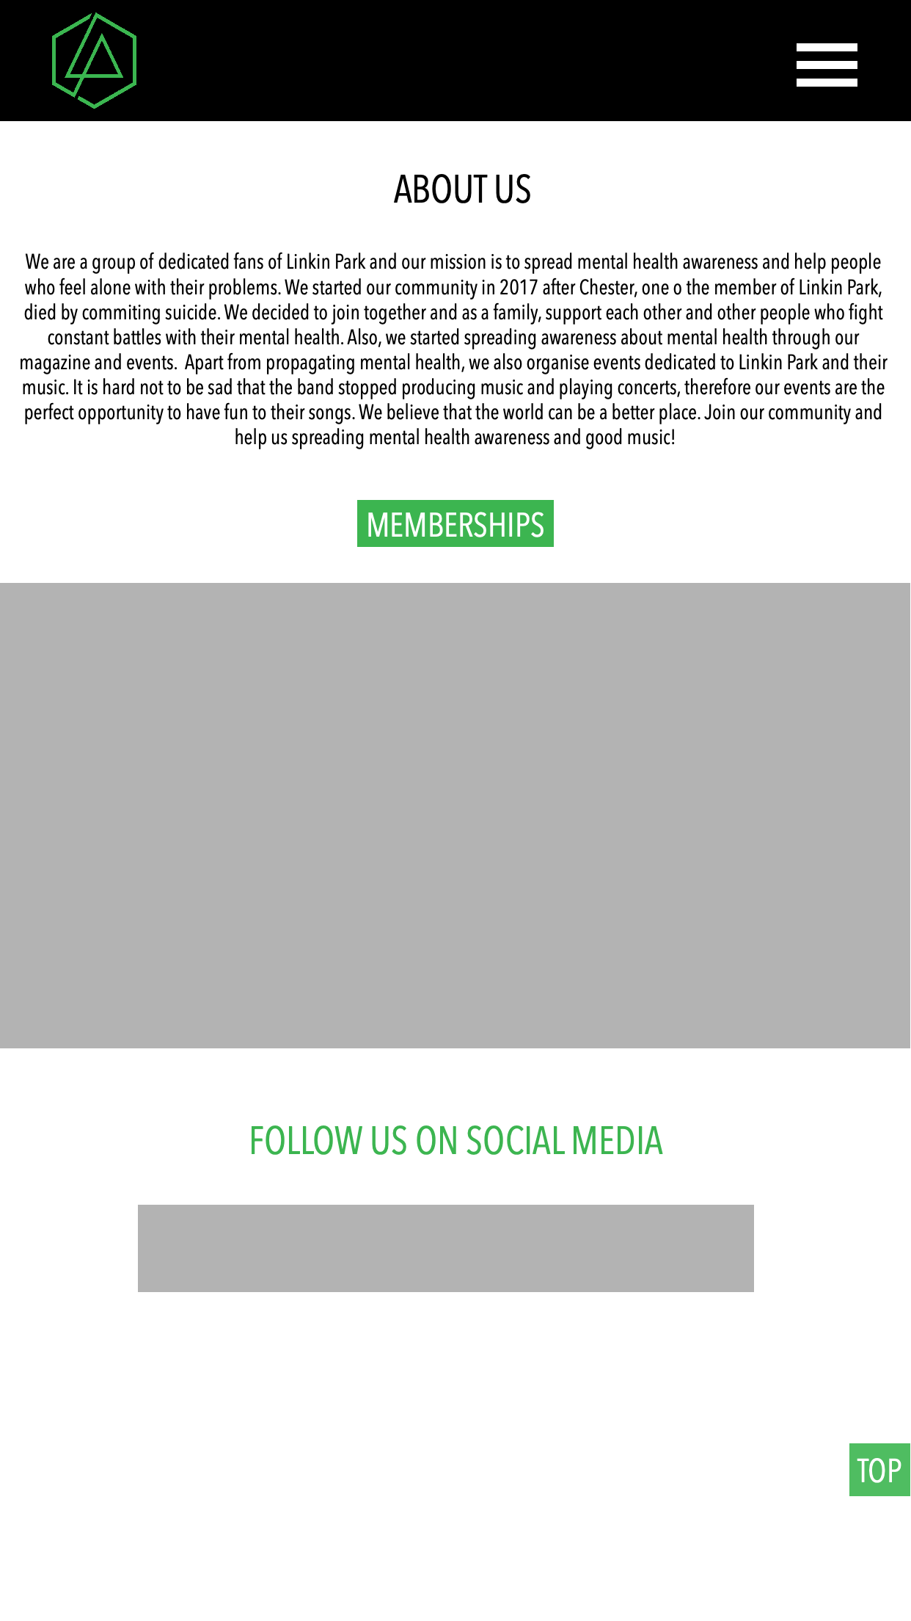



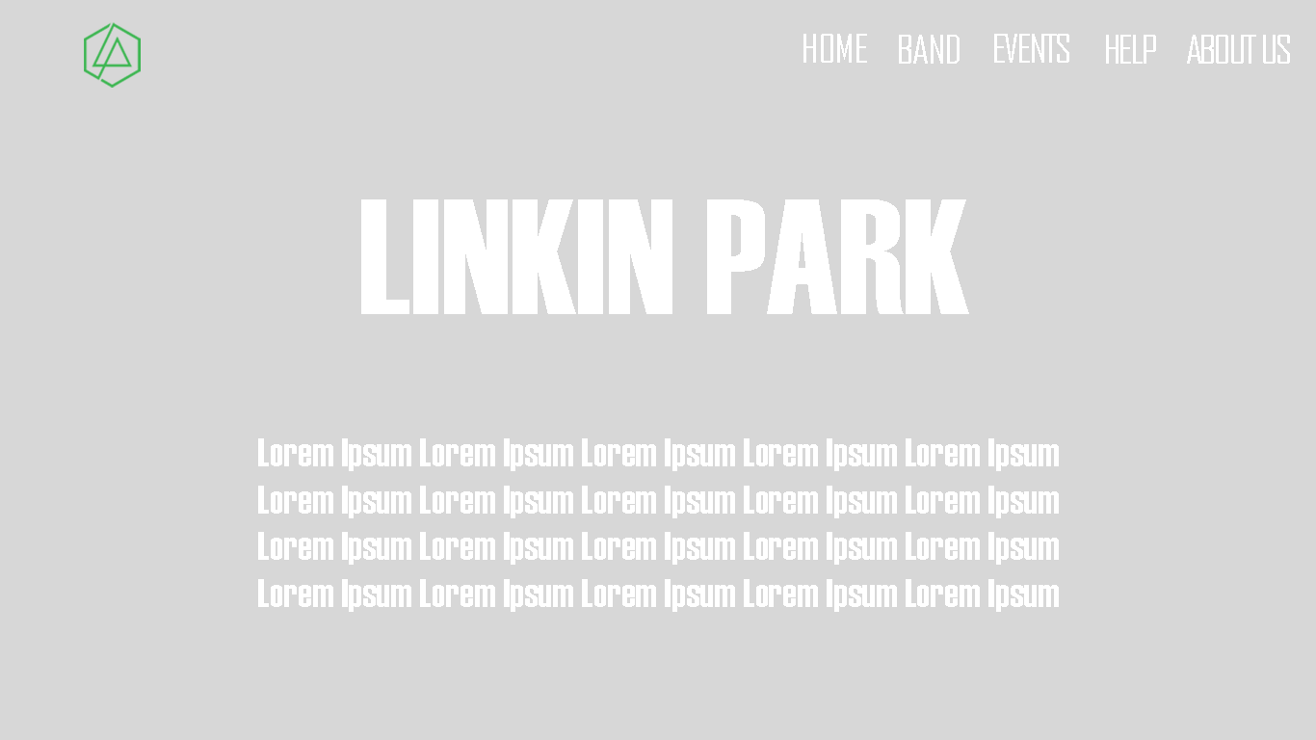



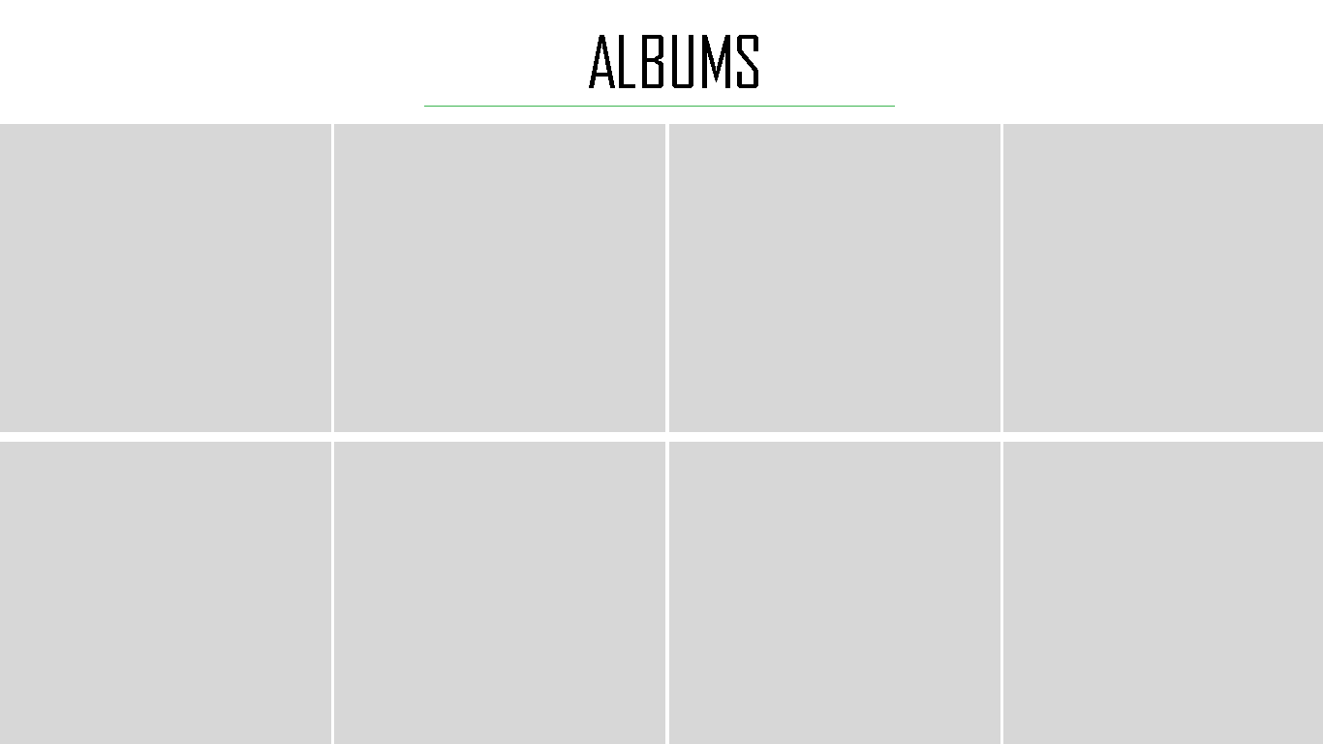

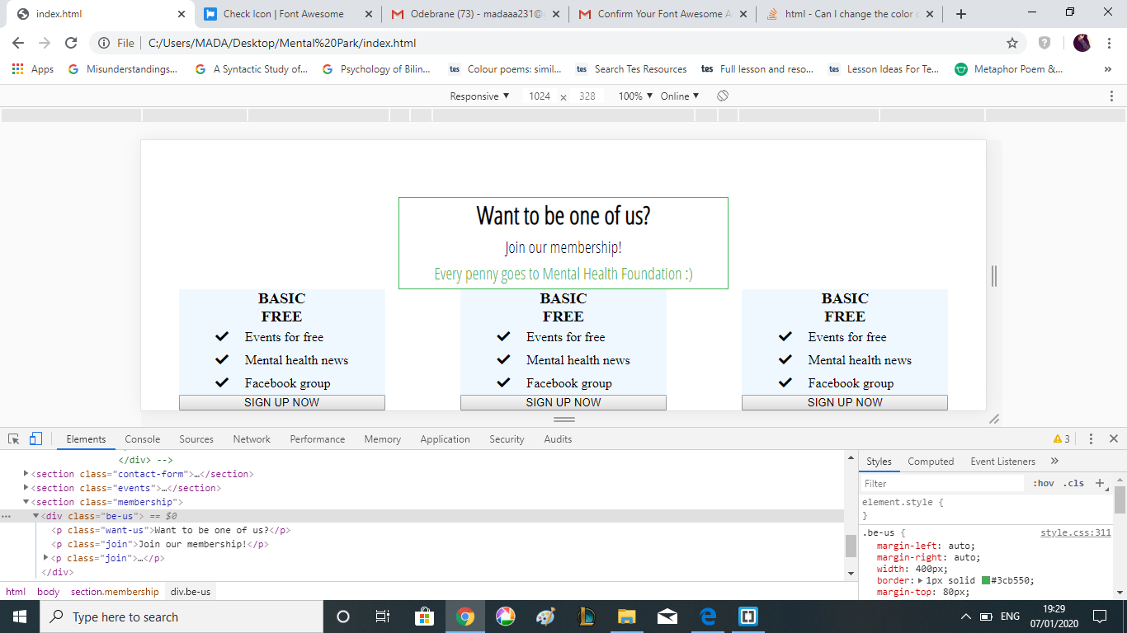

References:

Frain, B. (2015). *Responsive Web Design with HTML5 and CSS3* – Second Edition (Vol. Second edition). Birmingham: Packt Publishing.

Man-Hendriksen, B. (2016). *Advanced Responsive Layouts with CSS Flexbox: Flexible*

*Website Development Tool.* [WWW] Available from: <https://books.google.co.uk/books?id=1CZwDwAAQBAJ&printsec=frontcover&dq=Advanced+Responsive+Layouts+with+CSS+Flexbox:+Flexible+Website+Development+Tool.&hl=pl&sa=X&ved=0ahUKEwjOxJeqhMPoAhWTunEKHR2hD4AQ6AEIKzAA#v=onepage&q=Advanced%20Responsive%20Layouts%20with%20CSS%20Flexbox%3A%20Flexible%20Website%20Development%20Tool.&f=false> [Accessed 30/03/20].

McFedries, P. (2018). *Web Coding & Development All-in-One For Dummies.* New Jersey: John Wiley & Sons.